Foundation Phase Pupils
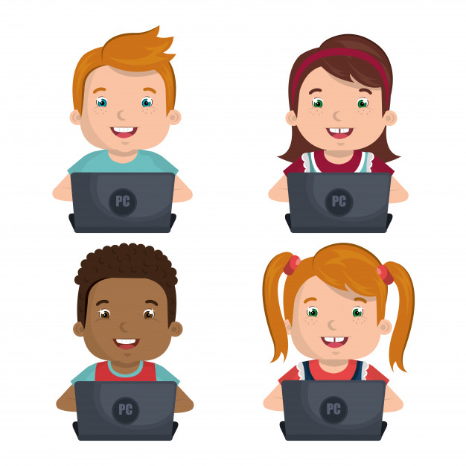


This is how we stay safe online:

- I will only use activities or platforms that a teacher or another adult from school has told or allowed me to use.
- I will take care of the computer and other equipment.
- I will ask for help from a teacher or another adult from the school if I am not sure what to do.
- I will try to learn my passwords and know how to keep them safe.
- I will tell a teacher or another adult from the school if I see something that upsets me on the screen using ‘Zip it, Block it, Flag it’
- I know that if I break the rules I might not be allowed to use a computer/ i-Pad.

Signed (child): Date:

Signed (parent): Date:

