Key Stage 2 Pupils

This is how we stay safe online:

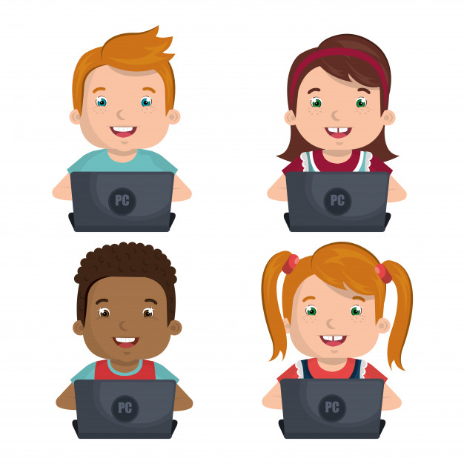


- I will ask a teacher or another adult from the school if I want to use a digital device.
- I will only use learning platforms that a teacher or another adult from the school has told or allowed me to use.
- I will take care of ICT equipment and reconnect it to the charging stations.
- I will ask for help from a teacher or another adult from the school if I am not sure what to do or if I think I have done something wrong.
- I will use the ‘Zip it, Block it, Flag it’ code if I see anything that upsets me or makes me feel uncomfortable online.
- I will act in a responsible and kind manner when I am online ensuring I only log in to my own accounts.
- I know that if I break the rules I might not be allowed to use a computer/tablet.

Signed (child): Date:

Signed (parent): Date:

